

AMERICAN INTERNATIONAL UNIVERSITY–BANGLADESH (AIUB)

Faculty of Science and Technology

Dept. of Computer Science

COURSE: SOFTWARE ENGINEERING

Fall 2025-2026

Section:V

Group No: 04

Software Requirement Specification [SRS] Document On

FOOD WASTE REDUCTION PLATFORM
Supervised By:
Zinniya Taffannum Pritee

Submitted By

Name |  | ID
1. | Tawfiqul Hasan | 23-54422-3
2. | Md. Rayatul Bari Rahin | 23-53450-3
3. | Md. Tanzim Wasif Shah | 23-53449-3
4. | Ibna Al Shaid Nipun | 23-53457-3
5. | Sazia Hassan Upoma | 22-47808-2

Table of Contents

1. INTRODUCTION 3
2. SCOPES & FEATURES 4
2.1 Scope 1: Surplus Food Analytics and Expiry Management 4
2.2 Scope 2: Intelligent Matching & Donation System 4
2.3 Scope 3: Pickup and Delivery Coordination and Food Safety 4
2.4 Scope 4: Volunteer & Community Impact Analytics 4
2.5 USE CASE DIAGRAM 5
3. USER STORY TABLE 6
4. REQUIREMENT TRACEABILITY MATRIX 7
4.1 Functional Requirements 7

INTRODUCTION
Food waste has emerged as a significant social, environmental and economic problem all over the globe. Every year, tons of edible food go to waste at home, restaurants, retail and supply chain levels. This waste results in not only a completely unnecessary financial loss, but also the adding of pressure to landfills and an increase in greenhouse-gas emissions. Yet at the same time, many neighborhoods remain beset by food insecurity. This breakdown betrays a large disparity between excess food and those who require it.

One of the biggest obstacles is that there is no easy, effective way to connect food providers with people or groups in search of surplus. Restaurants, hotels, grocery stores and homes frequently have extra food without an easy way of managing it, donate it or rotate it those who need it. Consumers also lack knowledge and information in real time that can lead to unnecessary trash at home, such as the expiration date tracking or receiving reminder.

A Food Waste Reduction Platform can fill the gap by providing a system for sharing, donating, tracking surplus food and raising awareness. As it links the giver; receiver and community and charitable groups in one online infrastructure, it aims to decrease waste while also fostering marginalized communities as well as ethical consumption.

OBJECTIVES

- Decrease food waste production for consumers, households and businesses.
- Keep a digital log of food surplus and expiry date
- Facilitate the real-time act of donation and sharing between donor and recipient parties
- Ensure NGOs, shelters and community programs have access to stable food sources.
- Use reminders and awareness tools for sustainable consumption
- Provide transparent and auditable redistribution mechanism
- Create an eco-space by minimizing waste
- Maximize public engagement in community-service projects

PROPOSED SOLUTION

The solution is thus a central, user-centered digital service that through proper redistribution and smart governance will seek to reduce food waste. Key components include:

Surplus Food Tracking: Excess food with expiration date, quantity and category can be recorded by users for instant visibility.
Smart Donation & Sharing System: Nearby NGOs/homes/families/individuals can instantly claim available food via automated matching.
Pickup & Delivery Coordination: Scheduling tools aggregate donors with volunteers or delivery partners to provide for efficient transportation.
Food Safety & Quality Monitoring: Timestamps and automated checks as well as guidelines let your shared food stay safe to eat.
Community Engagement: Features Gamification, green campaigns and sustainability education combine to promote engagement and environmentally friendly behavior.
Data Analytics & Reporting: It monitors the waste reduction, shares the amount of food and its impact on community with real insights.
Scalability & Accessibility: The user-friendly design is mobile compatible making it accessible to households, restaurants, retailers and small businesses.

TARGET AUDIENCE

Family: Waste less and share extra food.
Restaurants & Cafés: Give surplus food a safe drop with maximum ease
Grocery Stores & Businesses: Post your soon to expire stock for redistribution
NGOs & Community Shelters: Get regular supply of food.
Volunteers & Delivery Networks: Help deliver donated food
Ecologically Individuals: Help the environment to maintain sustainability

EXPECTED IMPACT

Major decrease in food waste from households and commercials causes
More food assistance for the downtrodden
Improved environmental sustainability
Strengthened community cooperation
Enhanced awareness about responsible consumption
Less waste in landfills and less carbon emissions

SCOPES & FEATURES

Scope 1: Surplus Food Analytics and Expiry Management
- Users can enter surplus food in terms of categories, quantity, and expiry date.
- To reduce the waste of food at home, the system sends reminders before food goes bad.
- Gives you a digital record for boosted food tracking.

Scope 2: Intelligent Matching & Donation System
- It instinctively finds the nearest donors for NGOs, shelters or quote unquote needy people.
- Food can be claimed by receivers on demand.
- Ensures quick and effective re-distribution of excess food.

Scope 3: Pickup and Delivery Coordination and Food Safety
- Delivery partners or volunteers can schedule pick-up and drop-off.
- Route optimization ensures timely delivery.
- Cliff provides details about food safety guidelines and timestamps to allow the donated food to maintain safety.

Scope 4: Volunteer & Community Impact Analytics
- Involves gamification, social awareness campaigns, and sustainability education.
- Keeps track of reduction of waste, donations given, and the effect on the environment
- Provides an incentive for the community to get involved by being transparent and offering a utility within the token.

USE CASE DIAGRAM
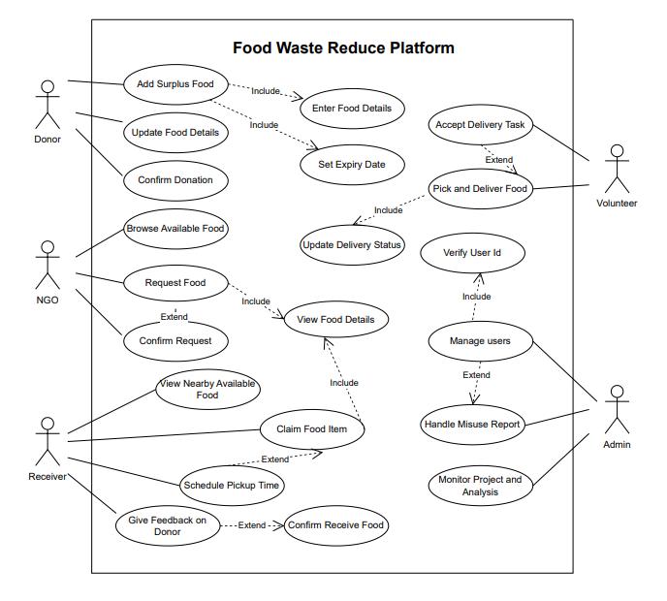
Figure: Use Case Diagram of Food Waste Reduction Platforms

Food Waste Reduction Platform Use Case Diagram According to different actors in the system and how they engage with the system to facilitate food donation, distribution, and management. Donor: Adding excess food, Updating food details and Confirming donation All these actions requires entering food detail with expiry dates perishable nature of the food. The NGO Recipient can view the listed available food and place a request on the items they wish to request, the request process includes viewing the details of the food, right until confirming the request. The Receiver, either a person or a family, can see available excess food around them, pick up food, arrange when to collect them, and leave optional feedback for the donors; picking up food means seeing their details (which may also enter the confirmation of receipt). The Volunteer or delivery partner who is notified and accepts the order is responsible for food pickup and drop-off while updating delivery status. The Admin can manage users, verify identities, monitor analytics, and handle reports of misuse (or anything else they want) and keep the system running smoothly. All of these interactions together provide an end-to-end view of the donor-receiver flow through the specific roles and interactions that must occur to facilitate the effective, safe, and transparent redistribution of food.

USER STORY TABLE
As a / An | I want to | So that | Acceptance Criteria
Donor | add surplus food | I can donate extra items instead of wasting them | System allows entering food name, quantity, category, and description
Donor | update food details | the information remains accurate | Updated food information is saved and shown correctly
Donor | confirm my donation | I know it has been successfully submitted | Donation status changes to confirmed
NGO Recipient | browse available food | I can request items for our community | List of available food items is displayed
NGO Recipient | request food | we can receive supplies when needed | Requested food is marked as pending
NGO Recipient | confirm received food | the donation record is complete | Donation status changes to received
Receiver (Individual/Family) | view nearby available food | I can find support easily | Food list is shown based on location
Receiver | claim food items | I can receive food safely and quickly | Claimed food is reserved for the receiver
Receiver | schedule a pickup time | collecting the food becomes convenient | Pickup time is saved and confirmed
Receiver | give feedback on the donor | I can share my experience | Feedback is stored and visible to admin
Volunteer / Delivery Partner | accept delivery tasks | I can help distribute food | Task status updates to accepted
Volunteer / Delivery Partner | update delivery status | the platform reflects real-time progress | Status updates to Picked Up / On the Way / Delivered
Admin | verify user identities | the platform remains secure | User status changes to verified
Admin | manage users | the system runs smoothly | Admin can add, update, or remove users
Admin | handle misuse reports | inappropriate activities are controlled | Reports can be reviewed and resolved
Admin | monitor reports and analytics | I can understand system performance | Analytics dashboard is accessible

REQUIREMENT TRACEABILITY MATRIX

Functional Requirements
Donor Requirements:
Donor will be able to add any surplus food with the details regarding Food name, Quantity, Category and Expiry Date under this system so that excess food can be donated rather than being wasted. So, to make sure that the donation process is accurate and complete, the system will need to provide features that can enable the donors to update the details of their food and confirm its donation. These are all high priority tasks and confirming a donation is medium priority.
NGO Recipient Requirements:
NGO recipients allow to view what food items are available and place an order for food items they need, making the process of getting food to communities more efficient. NGOs recipients must also be able to verify food received, to keep the donation records intact and transparent. As for browsing and getting the food, these should be set as a high priority and confirmation should be medium priority.
Individual Receiver Requirements:
The system shall allow individual receivers see available food nearby and claim items, thus enables food equity and accessibility. Also allow receivers to schedule their own pickup time and leave feedback to the system to make collection more convenient and increase trust on the platform. Viewing and claiming food are high-priority tasks, while pickup scheduling and feedback are medium to low priority.
Volunteer / Delivery Partner Requirements:
The system will allow delivery partners or volunteers to accept delivery tasks and update the delivery status, which allows them to transport the food with real-time tracking and pick up the food quickly. These are high-priority operational tasks.
Administrator Requirements:
The system will enable the admins to manage the users, verify personal identity verification, report misuse and analytics monitoring, to ensure that the system is secure, trustworthy and streamlined. These are high-priority administrative tasks.

